Tutorial class: Tuesday 11:30am

Tutor Name: Dr Amir Moradi

Excel Assignment Report

FIN60003: Business analysis and modelling

thi khanh hoa nguyen- 102227966

2019

# Executive Summary

This report aims to show the relationship of Fama and French three factor model to the World Market Index and Country Index. The analysis has been conducted to show the distribution of each variables by using histogram and the summary statistics of each variable also is shown in the tables. Following that, the confident interval and hypothesis testing is conducted to analyse the relationship between three factors of Fama and French model. The analysis shows that there is no relationship among these factors. The last part discusses about the regression and correlation to find the relationship between the MSCI index with the Country indexes. The results point out that there are moderate positive linear relationships between those variables.

Table of Contents

Executive Summary 1

Introduction 3

Descriptive Statistics 3

Confidence Interval 8

Hypothesis Testing 9

Correlation and Regression 10

Conclusion 12

References 12

Appendix 13

Appendix 1a: Confidence interval for Rf 13

Appendix 1b: Confidence interval for RER 13

Appendix 2a: Hypothesis testing to test the argue that the average excess return of the market portfolio (Rm-Rf) is higher than the average of Risk-free rate of Return (Rf). 13

Appendix 2b: Hypothesis testing to test the different between the value premium (HML) and the size premium (SMB) factor 13

Appendix 2c: Hypothesis testing to test the different between the excess return on the market portfolio (Rm-Rf) and the size premium (SMB) factor. 14

Appendix 3a: The regression between the MSCI World Index and the country Equity market Index 14

Appendix 3b: The regression between the MSCI World Index and the country Real Exchange Rate (RER) 15

Appendix 3c: T test for Correlation between Equity Market Index and MSCI 15

Appendix 3d T test for Correlation between RER and MSCI 15

# Introduction

In this report, the seven variables namely MSCI World Index, four variables from Fama and French Model (RF, RM-RF, SMB, HML, RER) (Bundoo 2008), Equity market Index and RER will be analyzed by using the descriptive statistics and inferential statistics in excel. The report contains 4 sections: Descriptive Statistics, Confidence Interval, hypothesis Testing and Correlation and Regression.

# Descriptive Statistics

In the report, we are analyzing 7 variables including MSCI World index, Four variables in Farma and French Model (RF, RM-RF, SMB, HML, RER), Equity Market Index and RER.

1. **The MSCI World index**: is a broad global equity index that represents the net return of large and mid-capitalization stocks across 23 developed market. The histogram shows the frequency distribution of MSCI World index from 2014 to 2018 and the summary statistics is shown in the table

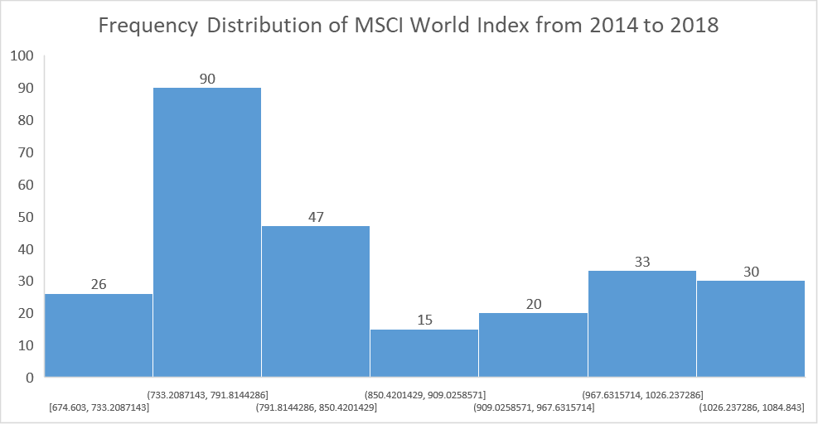

|  |  |
| --- | --- |
| **MSCI World Index** | |
| Mean | 849.4777969 |
| Standard Error | 6.926261818 |
| Median | 800.077 |
| Standard Deviation | 111.8971842 |
| Range | 410.24 |
| Minimum | 674.603 |
| Maximum | 1084.843 |

1. **Rf:** Risk free rate return at time t. The histogram shows the frequency distribution of RF from 2014 to 2018 and the summary statistics is shown in the table.

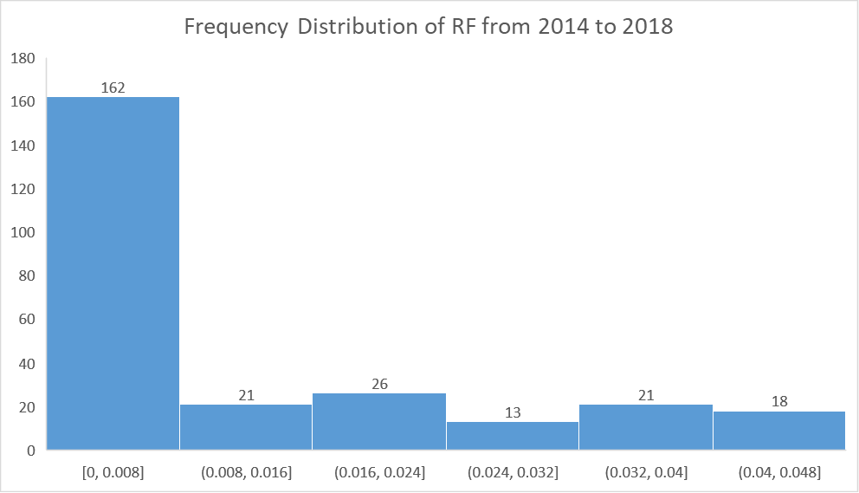

|  |  |
| --- | --- |
| **Rf** | |
| Mean | 0.011750958 |
| Standard Error | 0.000904412 |
| Median | 0.005 |
| Mode | 0 |
| Standard Deviation | 0.01461122 |
| Range | 0.048 |
| Minimum | 0 |
| Maximum | 0.048 |

1. **Rm-Rf**: is the excess return on the market portfolio (index)**.** The histogram shows the frequency distribution of RM-RF from 2014 to 2018 and the summary statistics is shown in the table.

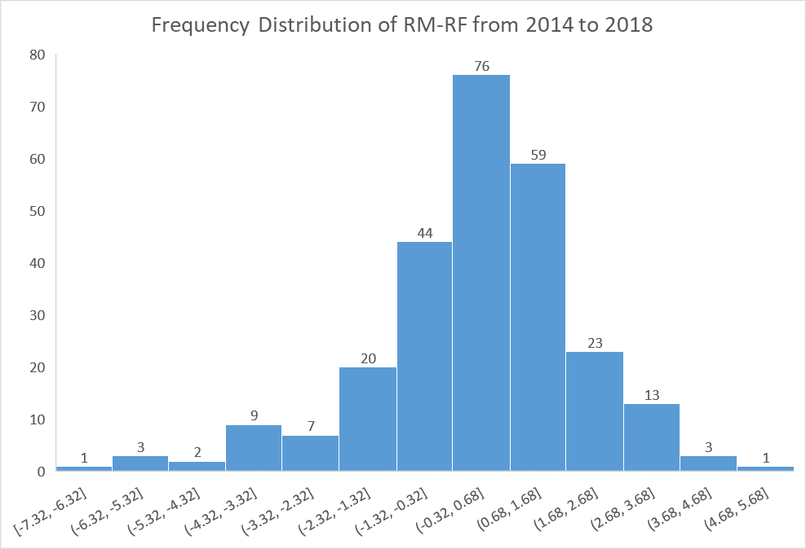

|  |  |
| --- | --- |
| **RM - Rf** | |
| Mean | 0.145747126 |
| Standard Error | 0.112945818 |
| Median | 0.3 |
| Mode | 1.38 |
| Standard Deviation | 1.824695527 |
| Range | 12.1 |
| Minimum | -7.32 |
| Maximum | 4.78 |

1. **SMB**: historic excess returns of small-cap companies over large-cap companies. The histogram shows the frequency distribution of SMB from 2014 to 2018 and the summary statistics is shown in the table.

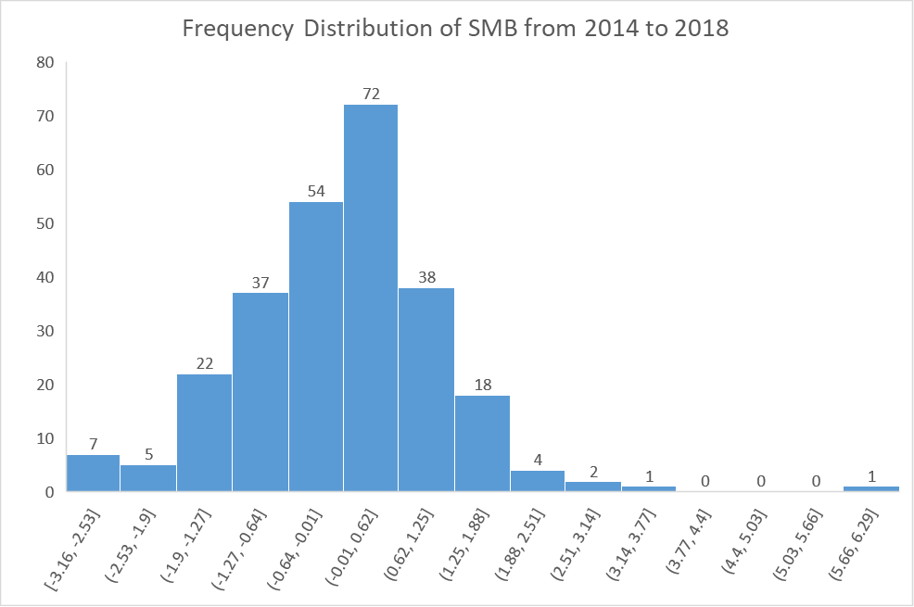

|  |  |
| --- | --- |
| **SMB** | |
| Mean | 0.049233716 |
| Standard Error | 0.07075762 |
| Median | 0.02 |
| Mode | -0.55 |
| Standard Deviation | 1.14312434 |
| Range | 9.21 |
| Minimum | -3.16 |
| Maximum | 6.05 |

1. **HML**: Historic excess returns of value stocks over the growth stocks. The histogram shows the frequency distribution of HML from 2014 to 2018 and the summary statistics is shown in the table.

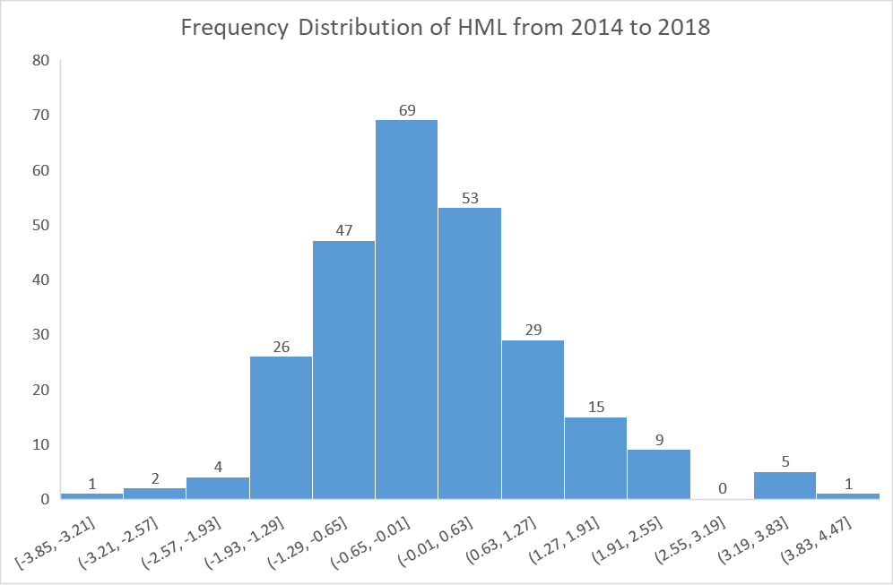

|  |  |
| --- | --- |
| **HML** | |
| Mean | -0.04908046 |
| Standard Error | 0.071839989 |
| Median | -0.14 |
| Mode | -0.08 |
| Standard Deviation | 1.160610548 |
| Range | 7.76 |
| Minimum | -3.85 |
| Maximum | 3.91 |

1. **Equity Market Index**: captures the net return of large and mid-capitalization stocks in a specific country. The histogram shows the frequency distribution of Equity Market Index from 2014 to 2018 and the summary statistics is shown in the table.

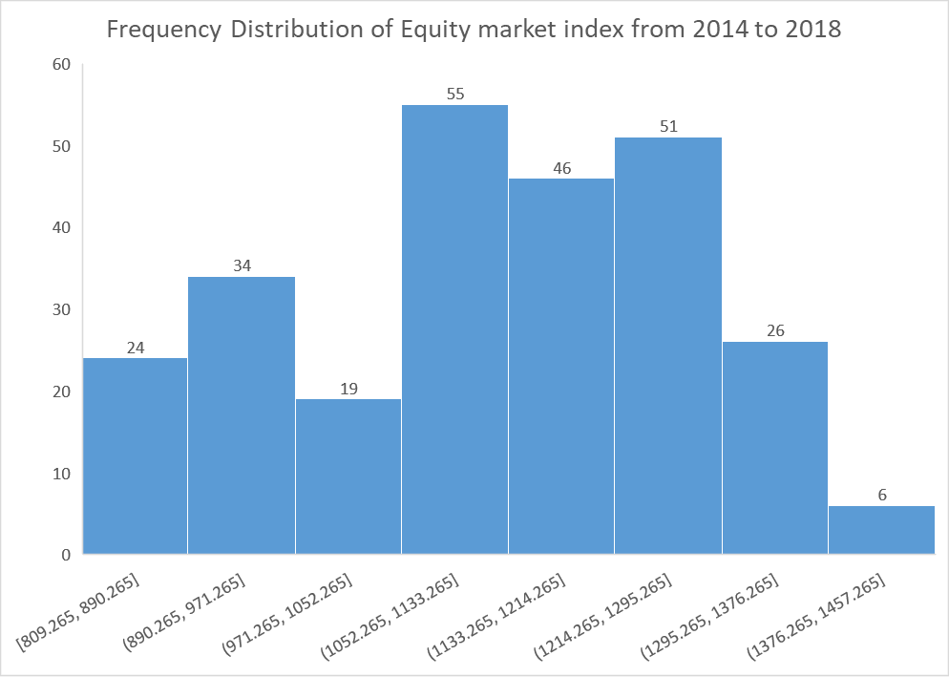

|  |  |
| --- | --- |
| **Equity Market Index** | |
| Mean | 1120.268805 |
| Standard Error | 9.164346547 |
| Median | 1133.055 |
| Mode | 1263.327 |
| Standard Deviation | 148.0545495 |
| Range | 602.896 |
| Minimum | 809.265 |
| Maximum | 1412.161 |

1. **RER**: Real Exchange Rate: measures the prices of one country’s goods and services related to those of another country. The histogram shows the frequency distribution of RER from 2014 to 2018 and the summary statistics is shown in the table.

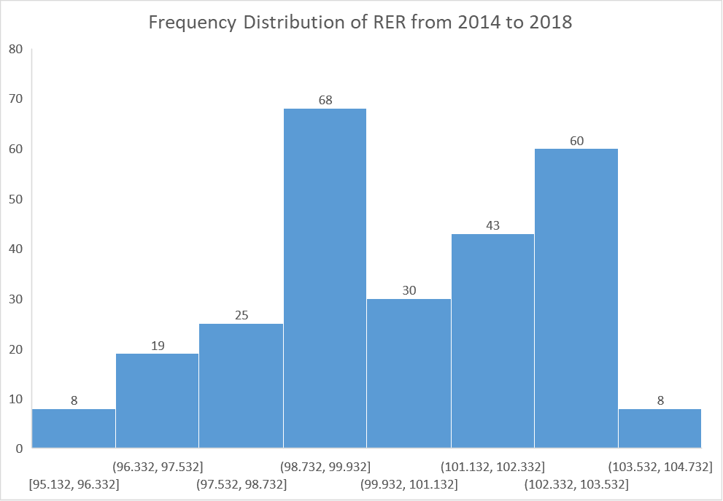

|  |  |
| --- | --- |
| **RER** | |
| Mean | 100.4808889 |
| Standard Error | 0.132328406 |
| Median | 100.184 |
| Mode | 102.238 |
| Standard Deviation | 2.137830822 |
| Range | 9.36 |
| Minimum | 95.132 |
| Maximum | 104.492 |

# 

# Confidence Interval

1. Confidence interval for Rf:

Our confidence interval has a limit of 0.00997 and 0.01352. We are 95% confident that the true mean will lie within the interval. We are about 5% sure that the population mean will not lie in this interval. (Please refer to appendix 1a for detail)

1. Confidence Interval for RER:

Our confidence interval has a limit of 100.741 and 100.2203. We are 95% confident that the true mean will lie within the interval. We are about 5% sure that the population mean will not lie in this interval (Please refer to appendix 1b for detail)

# Hypothesis Testing

1. Hypothesis testing was performed to test the argue that the average excess return of the market portfolio (Rm-Rf) is higher than the average of Risk free rate of Return (Rf). It is one tailed test (upper tail), independent samples.

|  |  |
| --- | --- |
| df | 520 |
| t Stat | -1.18634 |
| P(T<=t) one-tail | 0.118015 |
| t Critical one-tail | 1.647789 |

As the t-statistic is less than the t-critical one-tail (--1.18634<1.647789), we accept that the average excess return of the market portfolio (Rm-Rf) is not higher than the average of Risk free rate of Return (Rf) (Please refer to appendix 2a for detail.)

1. Hypothesis testing was performed to test the different between the value premium (HML) and the size premium (SMB) factor. It is two-tailed test, independent samples.

|  |  |
| --- | --- |
| df | 520 |
| t Stat | -0.00152 |
| P(T<=t) two-tail | 0.998788 |
| t Critical two-tail | 1.964537 |

As the t-statistic is in between two value of t-critical two-tail (-1.964537<-0.0152<1.964537), we accept that there is no different between the value premium (HML) and the size premium (SMB) factor (Please refer to appendix 2b for detail).

1. Hypothesis testing was performed to test the different between the excess return on the market portfolio (Rm-Rf) and the size premium (SMB) factor. It is two-tailed test, independent samples. The detail of the hypothesis testing is shown as follow:

|  |  |
| --- | --- |
| df | 520 |
| t Stat | 1.462948 |
| P(T<=t) two-tail | 0.144086 |
| t Critical two-tail | 1.964537 |

As the t-statistic is in between two value of t-critical two-tail (-1.964537<1.462948<1.964537), we accept that there is no different between the excess return on the market portfolio (Rm-Rf) and the size premium (SMB) factor (Please refer to appendix 2c for detail)

# Correlation and Regression

1. The regression between the MSCI World Index and the country Equity market Index. (Please refer to appendix 3a for detail)

Independent variable: Equity market Index

Dependent variable: MSCI World Index

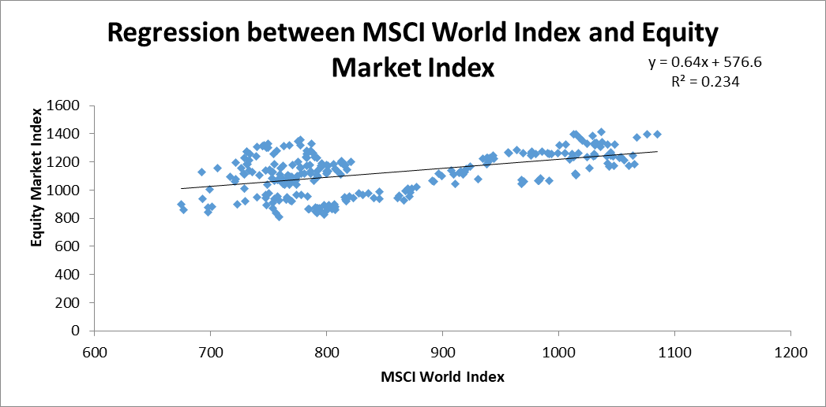

Equation: **Equity Market Index = 576.6+ 0.64 × MSCI World Index**

**576.6:** is the estimated average value of Equity market Index when the value of MSCI World Index is zero.

**0.64**: is the estimated change in the average value of Equity Market Index as a result of a one-unit change in the MSCI World Index.

**Multiple R = 0.4837**. It shows that there is a moderate positive linear relationship between he MSCI World Index and the Equity market index.

**Coefficient of determination (R2) = 0.234**. This means that 23.4% of the variation in the Equity Market Index for this sample can be explained by the linear relationship between MSCI and Equity market index. This leaves 76.6% of variations in Equity market index unexplained.

1. The regression between the MSCI World Index and the country Real Exchange Rate (RER) (Please refer to appendix 3b for detail)

Dependent variable: RER

Independent Variable: MSCI World Index

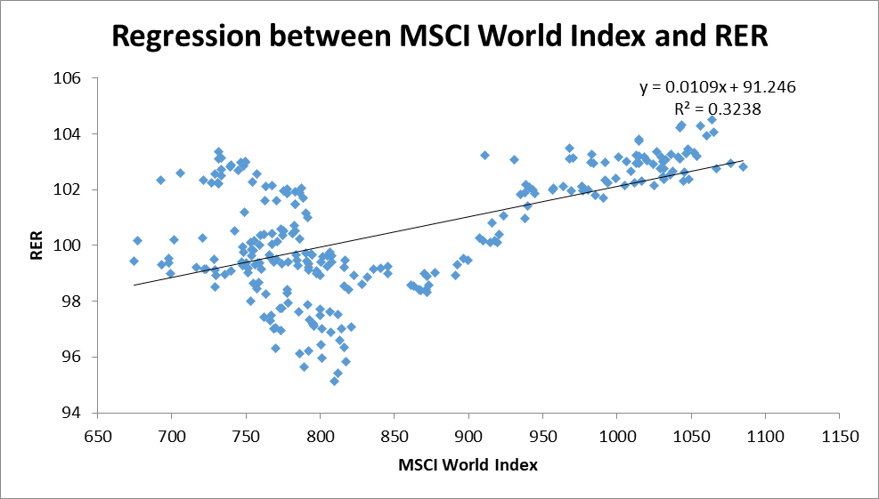

Equation**: RER = 91.246+ 0.0109 × MSCI World Index**

**91.246:** is the estimated average value of RER when the value of MSCI World Index is zero

**0.0109**: is the estimated change in the average value of RER as a result of a one-unit change in the MSCI World Index

**Multiple R = 0.569**. It shows that there is a moderate positive linear relationship between the MSCI World Index and the RER.

**Coefficient of determination (R2) =** 0.3238. This means that 32.38% of the variation in the RER for this sample can be explained by the linear relationship between MSCI and RER. This leaves 67.62 % of variations in RER unexplained.

1. Significant test for the Correlation

* T test for Correlation between Equity Market Index and MSCI

t-statistic = 8.894, d.f = 259, t-critical= 2.2545

As the t-statistic is greater than t-critical, there is evidence of a linear association at the 5% level of significance between Equity Market Index and MSCI ((Please refer to appendix 3c for detail)

* T test for Correlation between RER and MSCI

t-statistic = 11.13, d.f = 259, t-critical= 2.2545

As the t-statistic is greater than t-critical, there is evidence of a linear association at the 5% level of significance between RER and MSCI (Please refer to appendix 3d for detail)

# Conclusion

After analyzing the seven variables by using descriptive and inferential statistics, it can be concluded that there are some relationships between MSCI and Country Indexes. On the other hand, there is no evidence for the relationship between three factors in Fama and Frech model. As we are using the descriptive and inferential statistics in this report, there are some limit that can be listed. Firstly, the descriptive statistics is used for making summation about a particular variable, hence, it can not be used to generalize other variables. Secondly, we are testing the hypothesis tests and regression and correlation based on sample that is collected from five consecutive years form the population, hence, there is come uncertainty about the correctness of the results. To ensure the ethics in statistics, it is required the high accurate in data collection and data interpretation. The personal biases to the data collection and interpretation cold lead to the misrepresentation of the data.

# References

Bundoo, SK 2008, ‘An augmented Fama and French three-factor model: new evidence from an emerging stock market’, *Applied Economics Letters*, vol. 15, no. 15, pp. 1213–1218.

Groebner, D. F., Shannon, P. W., & Fry, P. C. (2018). *Business statistics: a decision-making approach*

# Appendix

## Appendix 1a: Confidence interval for Rf

|  |  |
| --- | --- |
| *Rf* | |
| Confidence Level (95.0%) | 0.001780904 |
| Mean | 0.011750958 |
| Upper limit | 0.013531862 |
| Lower limit | 0.009970053 |

## Appendix 1b: Confidence interval for RER

|  |  |
| --- | --- |
| *RER* | |
| Confidence Level (95.0%) | 0.260571834 |
| Mean | 100.4808889 |
| Upper limit | 100.7414607 |
| Lower limit | 100.2203171 |

## Appendix 2a: Hypothesis testing to test the argue that the average excess return of the market portfolio (Rm-Rf) is higher than the average of Risk-free rate of Return (Rf).

|  |  |  |
| --- | --- | --- |
| t-Test: Two-Sample Assuming Equal Variances |  |  |
|  | *Rf* | *RM - Rf* |
| Mean | 0.011751 | 0.145747 |
| Variance | 0.000213 | 3.329514 |
| Observations | 261 | 261 |
| Pooled Variance | 1.664864 |  |
| Hypothesized Mean Difference | 0 |  |
| df | 520 |  |
| t Stat | -1.18634 |  |
| P(T<=t) one-tail | 0.118015 |  |
| t Critical one-tail | 1.647789 |  |
| P(T<=t) two-tail | 0.236031 |  |
| t Critical two-tail | 1.964537 |  |

## Appendix 2b: Hypothesis testing to test the different between the value premium (HML) and the size premium (SMB) factor

|  |  |  |
| --- | --- | --- |
| t-Test: Two-Sample Assuming Equal Variances |  |  |
|  | *SMB* | *HML* |
| Mean | -0.04923 | -0.04908 |
| Variance | 1.306733 | 1.347017 |
| Observations | 261 | 261 |
| Pooled Variance | 1.326875 |  |
| Hypothesized Mean Difference | 0 |  |
| df | 520 |  |
| t Stat | -0.00152 |  |
| P(T<=t) one-tail | 0.499394 |  |
| t Critical one-tail | 1.647789 |  |
| P(T<=t) two-tail | 0.998788 |  |
| t Critical two-tail | 1.964537 |  |

## Appendix 2c: Hypothesis testing to test the different between the excess return on the market portfolio (Rm-Rf) and the size premium (SMB) factor.

|  |  |  |
| --- | --- | --- |
| t-Test: Two-Sample Assuming Equal Variances |  |  |
|  | *RM - Rf* | *SMB* |
| Mean | 0.145747 | -0.04923 |
| Variance | 3.329514 | 1.306733 |
| Observations | 261 | 261 |
| Pooled Variance | 2.318124 |  |
| Hypothesized Mean Difference | 0 |  |
| df | 520 |  |
| t Stat | 1.462948 |  |
| P(T<=t) one-tail | 0.072043 |  |
| t Critical one-tail | 1.647789 |  |
| P(T<=t) two-tail | 0.144086 |  |
| t Critical two-tail | 1.964537 |  |

## Appendix 3a: The regression between the MSCI World Index and the country Equity market Index



## Appendix 3b: The regression between the MSCI World Index and the country Real Exchange Rate (RER)



## Appendix 3c: T test for Correlation between Equity Market Index and MSCI

|  |  |
| --- | --- |
| t statistic | 8.894 |
| df | 259 |
| t critical | 2.254508761 |

## Appendix 3d: T test for Correlation between RER and MSCI

|  |  |
| --- | --- |
| t statistic | 11.13 |
| df | 259 |
| t critical | 2.254508761 |